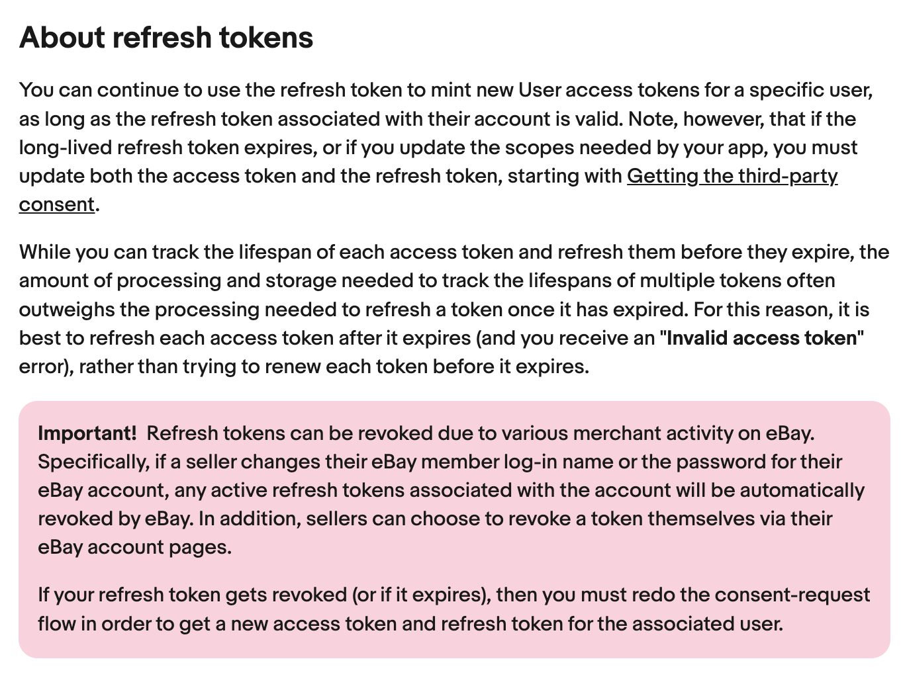
About refresh tokens
You can continue to use the refresh token to mint new User access tokens for a specific useras long as the refresh token associated with their account is valid. Note, however, that if theong-lived refresh token expires, or if you update the scopes needed by your app, you mustupdate both the access token and the refresh token, starting with Getting the third-partyconsent.
While you can track the lifespan of each access token and refresh them before they expire, theamount of processing and storage needed to track the lifespans of multiple tokens oftenoutweighs the processing needed to refresh a token once it has expired. For this reason, it isbest to refresh each access token after it expires (and you receive an "lnvalid access token"error), rather than trying to renew each token before it expires.
Important! Refresh tokens can be revoked due to various merchant activity on eBay.Specifically, if a seller changes their eBay member log-in name or the password for theireBay account, any active refresh tokens associated with the account will be automaticallyrevoked by eBay. In addition, sellers can choose to revoke a token themselves via theireBay account pages.
If your refresh token gets revoked (or if it expires), then you must redo the consent-requestflow in order to get a new access token and refresh token for the associated user.
关于刷新令牌
只要与特定用户的帐户关联的刷新令牌有效，您就可以继续使用刷新令牌为特定用户创建新的用户访问令牌。 但请注意，如果长期刷新令牌过期，或者更新应用程序所需的范围，则必须从获取第三方同意开始更新访问令牌和刷新令牌。
虽然您可以跟踪每个访问令牌的生命周期并在它们过期之前刷新它们，但跟踪多个令牌的生命周期所需的处理和存储量通常超过令牌过期后刷新令牌所需的处理量。 因此，最好在每个访问令牌过期后刷新它（并且您会收到“无效的访问令牌”错误），而不是在每个令牌过期之前尝试更新它。
重要的！ 刷新令牌可能会因 eBay 上的各种商家活动而被撤销。具体来说，如果卖家更改其 eBay 会员登录名或 eBay 帐户的密码，则与该帐户关联的任何活动刷新令牌将被 eBay 自动撤销。 此外，卖家可以选择通过其 eBay 帐户页面自行撤销令牌。
如果您的刷新令牌被撤销（或过期），则您必须重做同意请求流程，以便为关联用户获取新的访问令牌和刷新令牌。

